HarrisAuctionsLLC
Florida
AB2873 On Site Auction and Liquidation Marketing AU3858

To be auctioned ABSOLUTE!!
Saturday, July 10th starting at 11:00am
3821 Stearns Road, Valrico 33596

2006 Husqvarna LZ6130 Zero Turn Commercial Mower
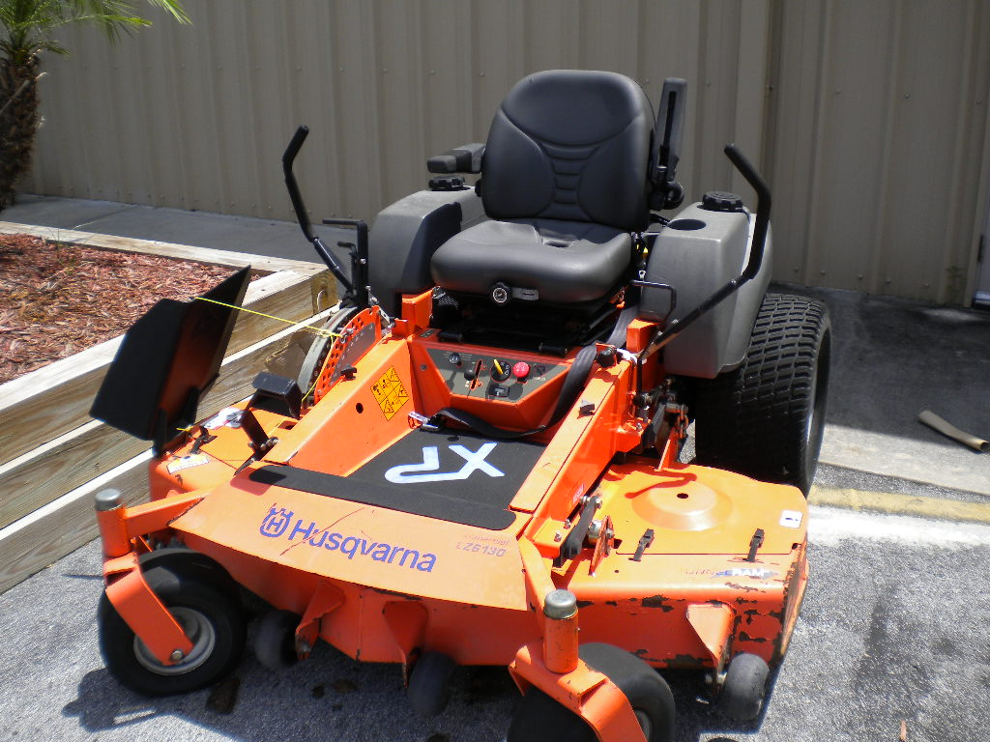
Model # 96899931 Serial #06469453
474 hours, not used commercially.
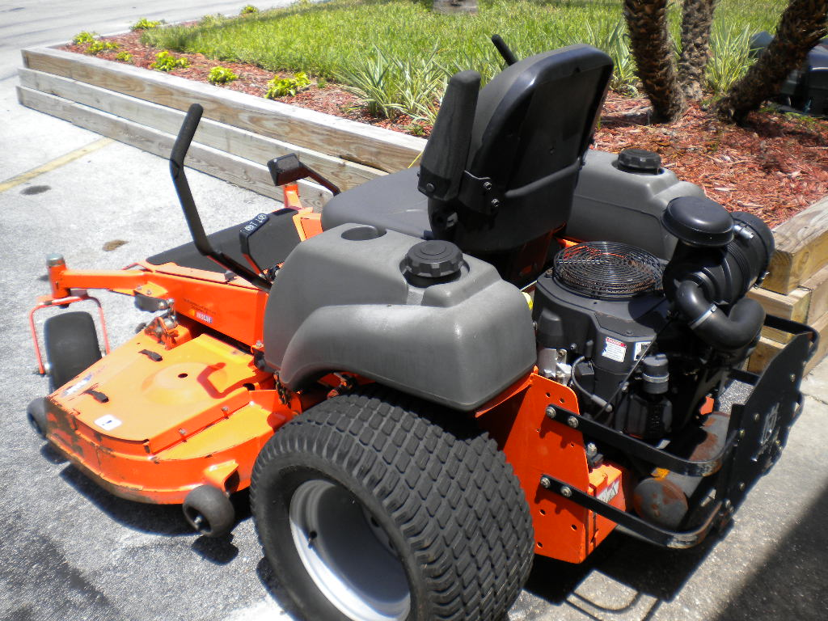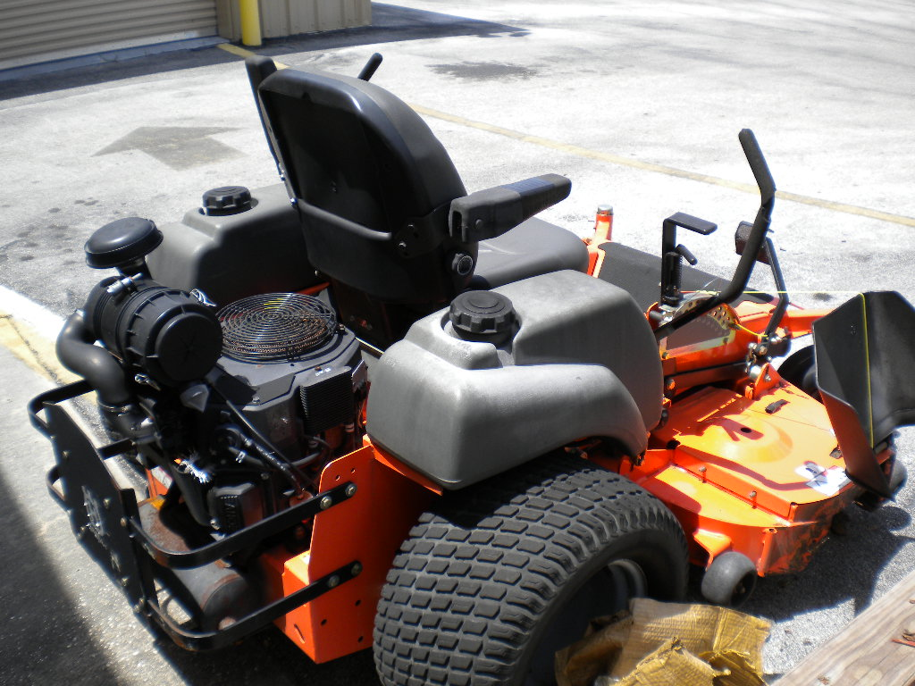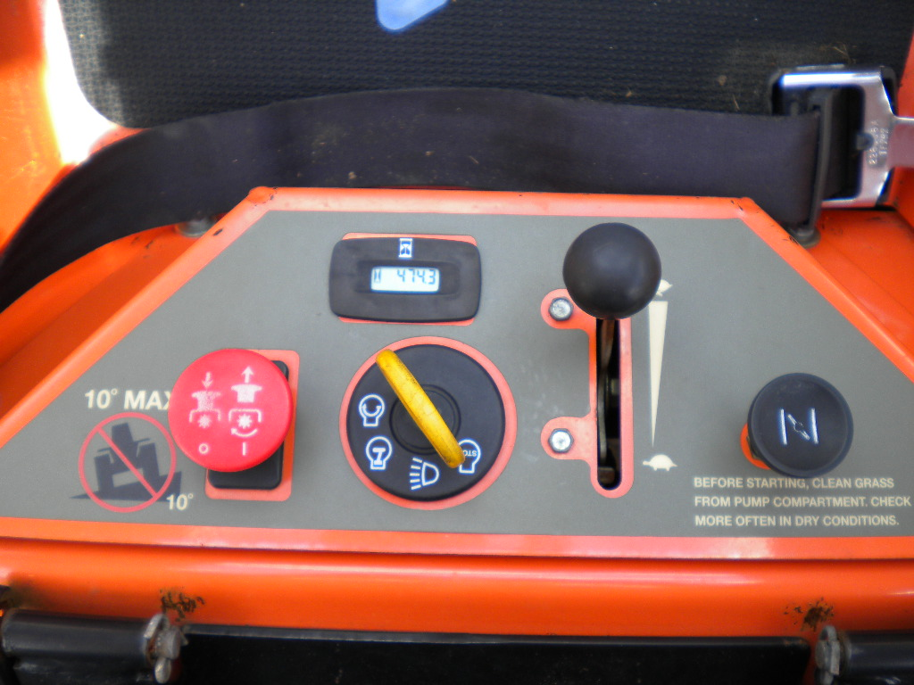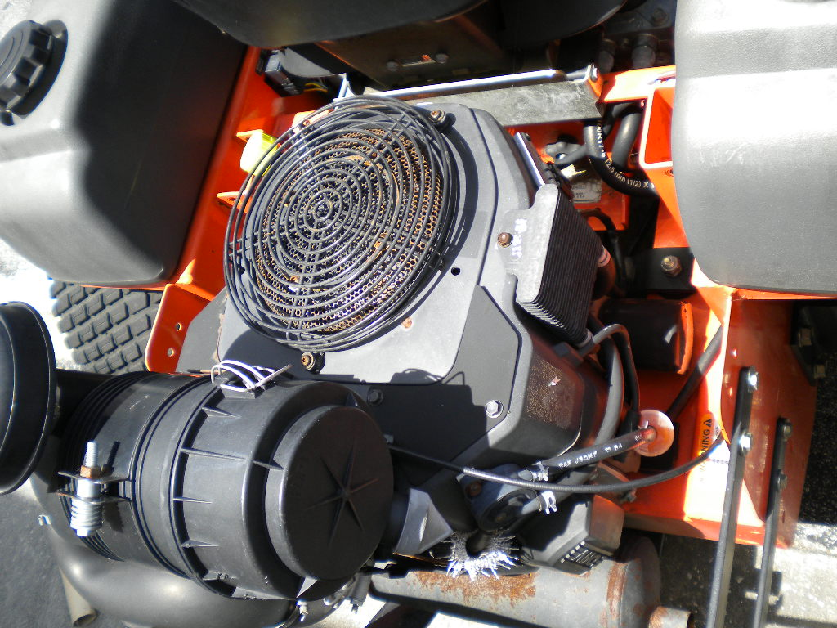
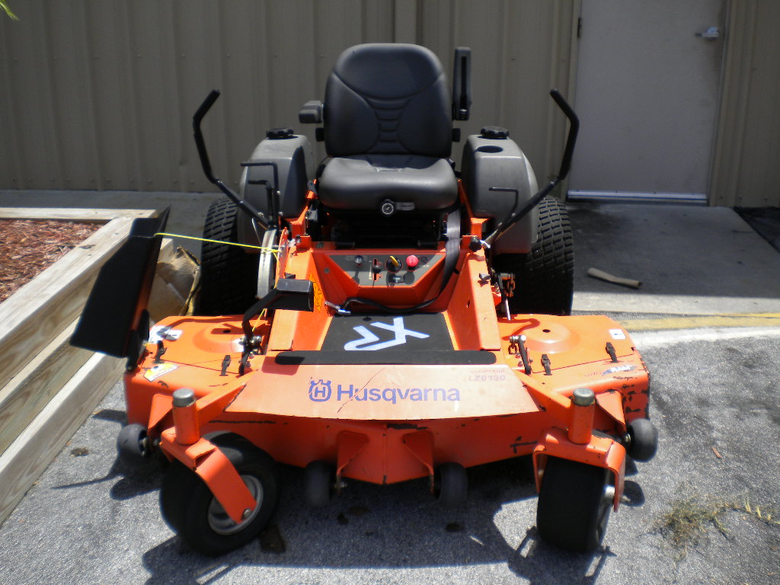
Buyer’s Premium 10% cash or check, 12% Visa, MasterCard
For more information contact John Harris 813-784-3926

